League 1  Brentwood/Bay Shore  Commack/Northport  Huntington/Walt Whitman  Smithtown  Connetquot/East Islip  Half Hollow Hills  Deer Park/North Babylon | League 2  Ward Melville  Sachem North  William Floyd  Central Islip  Lindenhurst  Sachem East | League 3  Sayville/Bayport-Blue Pt.  West Babylon  Hauppauge  Harborfields  EH/Pier/BH  West Islip

GIRLS SWIMMING COMBINED TEAMS
CONNETQUOT/E ISLIP – V
BRENTWOOD/BAY SHORE - V
HHHW/HHHE – V
SAYVILLE/BAYPORT-BP – V
DEER PARK/N BABYLON – V
SM WEST/SM EAST – V
EH/BH/PIER – V
NORTHPORT/COMMACK – V
HUNTINGTON/W WHITMAN - V

2019-20 HIGH SCHOOL SCHEDULING INFORMATION revised 6/10/19
SPORT | MAX # CONTESTS  ALLOWED | # PRACTICES  PRIOR TO 1st  SCRIMMAGE/CONTEST | FIRST  PRACTICE  DATE | FIRST  SCRIM/  CONTEST  DATE | NYS  CHAMP  DATE
G Swimming | 15 VAR | 6 | 8/26 | 9/2 | 11/22-23

+6 tournaments maximum
NOTE: FIRST SCRIMMAGE AND FIRST CONTEST DATES ARE BASED ON USING SATURDAYS AND HOLIDAYS AS PRACTICE DATES (EXCEPT THANKSGIVING DAY). If teams do not practice on Saturdays, and/or holidays, add one day for each practice missed. According to the Section XI Holy Day Policy approved on Dec 8, 1978, no contest or interschool scrimmage may be scheduled in Section XI on the dates listed below. Jewish holy days begin at sundown of the preceding day, and end at sundown of the day listed. Student-athletes must be able to be home by 6PM on days preceding Jewish holy days.

HOLY DAY OBSERVANCE |  |  | SIGNIFICANT DATES TO CONSIDER
Sept 30 & Oct 1 � Rosh Hashanah  Oct 9 � Yom Kippur  Dec 24 � Christmas Eve  Dec 25 � Christmas Day  Apr 8 � 1st Day of Passover  Apr 9 � Holy Thursday  Apr 10 � Good Friday  Apr 12 � Easter Sunday |  |  | Sept 2 � Labor Day  Oct 14 � Columbus Day  Oct 31 - Halloween  Nov 5 � Election Day  Nov 11 � Veterans� Day (observed)  Nov 28 � Thanksgiving Day  Jan 20 � Martin Luther King Jr. B-day (observed)  Feb 17 � Presidents� Day  May 25 � Memorial Day (observed)
STANDARD TEST DATES
Aug 24 - SAT  Sept 14 - ACT  Oct 5 � SAT & Achiev  Oct 16, 19 � PSAT  Oct 26 � ACT  Nov 2 � SAT & Achiev | Dec 7 � SAT & Achiev  Dec 14 � ACT  Feb 8 � ACT  March 14 � SAT  April 4 � ACT |  |  | May 2 � SAT & Achiev  June 6 � SAT & Achiev  June 13 � ACT

2019 GIRLS SWIMMING INDIVIDUAL COMPETITOR DATES
Sept 10 |  | Connetquot |  | 4:30 pm
Sept 13 |  | Sayville |  | 4:30 pm
Sept 17 |  | Deer Park |  | 4:30 pm
Sept 26 |  | Central Islip |  | 4:30 pm
Oct 4 |  | Sayville |  | 4:30 pm
Oct 7 |  | Deer Park |  | 4:30 pm
Oct 10 |  | Ward Melville |  | 4:30 pm
Oct 16 |  | Central Islip |  | 4:30 pm
Oct 22 |  | Sachem East |  | 4:30 pm
Oct 23 |  | Hauppauge |  | 4:30 pm
Please have lane lines in and counters available for the swimmers.
2019 Dive of the Week Schedule
Start of Season – Sept. 14 100 Forward Leagues 100 Forward
Sept. 15 – 21 200 Back County Championship 11 Dives
Sept. 22 – 28 400 Inward 440 Qualifies or Top 16
Sept. 29 – Oct. 5 5000 Twist
Oct. 6 – 12 300 Reverse
Oct. 13 – 19 100 Forward
Oct. 20 – 26 200 Back
Oct. 27 – Nov. 2 400 Inward
- If a school is competing outside of New York or is hosting a team outside of New York, coaches of both teams MUST agree on a voluntary dive 24 hours before the meet is contested.
- Meets rescheduled due to weather or some other unforeseen reason will use the dive from the originally scheduled date.
- Divers may use any dive from the scheduled group as their voluntary dive, but must be listed with a degree of difficulty no higher than 1.8.
2019 CHAMPIONSHIPS dates

10/29 - League 3 Championship Hauppauge HS 4:15 pm
League 2 Championship Sachem North HS 4:15 pm
10/30 - League 1 Championship Sachem North HS 4:15 pm
11/7 - Section XI Diving Championship Hauppague HS 4:30 pm
11/9 - Section XI Swimming Championship SCCC Brentwood 10 am
11/22-23 - NYPHSAA Championship, Ithaca College

2019 Girls Swimming & Diving Time Standards

County Meet State Meet

Yards Meters Event Yards Meters

2:11.95 2:27.95 200 Medley Relay 1:52.35 2:05.38
2:09.61 2:23.60 200 Free 1:57.24 2:09.90
2:28.69 2:45.04 200 IM 2:12.84 2:27.45
26.92 30.01 50 Free 24.84 27.69
169.80 or Top 16 Diving 440.00
1:08.35 1:15.93 100 Fly 1:00.02 1:06.68
1:00.51 1:07.28 100 Free 54.36 1:00.44
5:52.90 5:09.56 500 Free 5:14.65 4:36.01
1:59.25 2:13.20 200 Free Relay 1:41.69 1:53.58
1:07.58 1:15.09 100 Back 1:00.42 1:07.12
1:18.45 1:27.23 100 Breast 1:08.60 1:16.28
4:24.73 4:54.90 400 Free Relay 3:42.73 4:08.12

County Meet Qualifiers

All individual and relay automatic qualifiers are accepted.

We will not be taking swimmers just to fill in heats.

State Meet Qualifiers

All swimmers who qualify in-season are eligible.

Maximum of 2 individual entries are allowed at state meet.

1st Place finisher at county meet qualifies if there are no automatic qualifiers.

All in-season qualifiers must have paperwork submitted 24 hours after meet.

Yards Standards
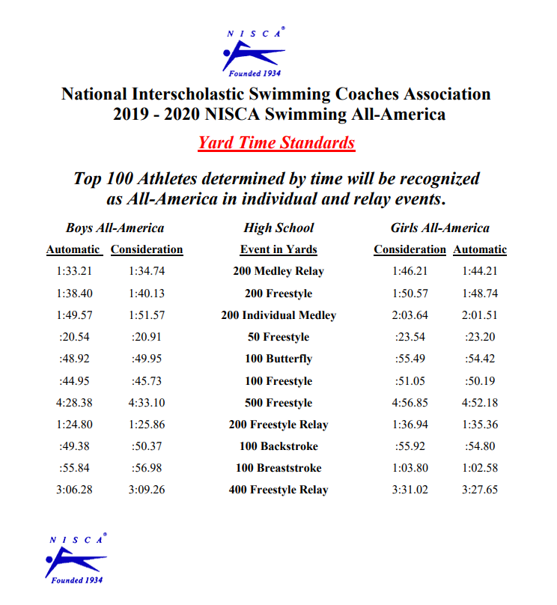
Meters Standards
