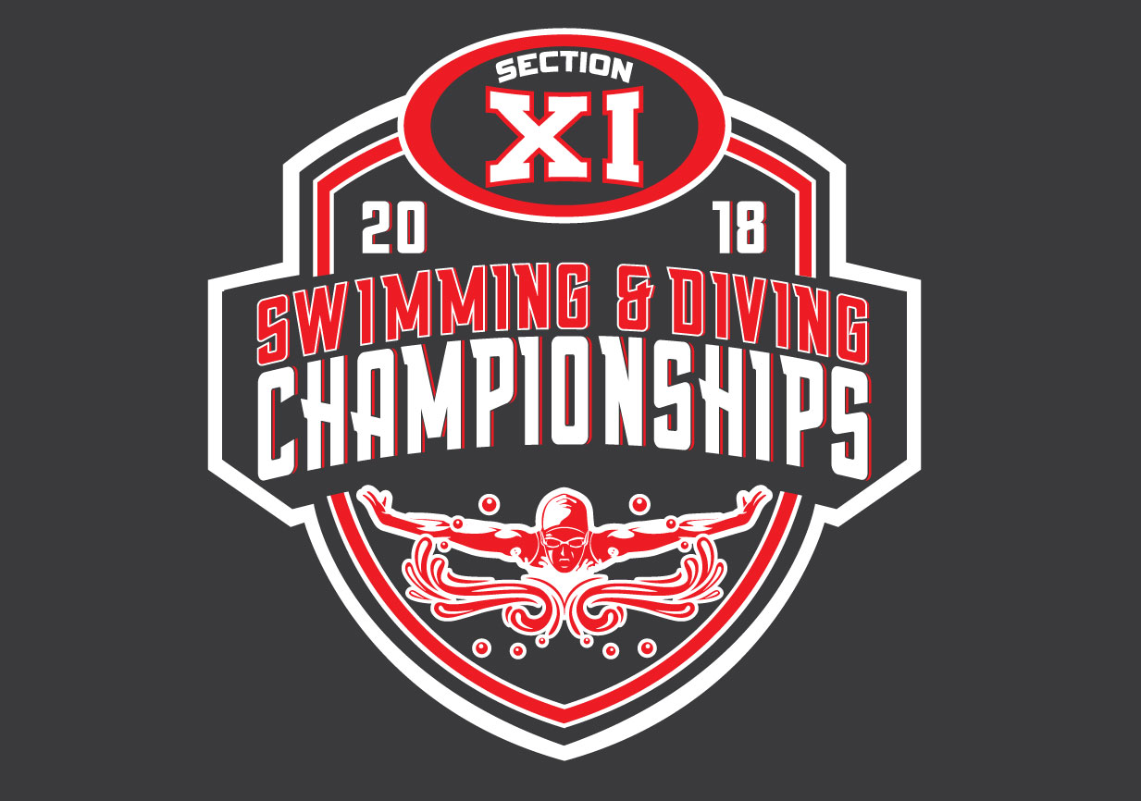

LONG SLEEVE T-SHIRTS $20

Coaches: We are doing bulk orders for shirts. Shirts will be available at the county championships. You will fill out order form for your team and send to me so that we can bundle the order. DEADLINE FOR ORDERS: Friday, Oct. 26th
Email to me: lionettir@hauppauge.k12.ny.us

TEAM: COACH:

QUANTITY ORDERED: SMALL:

MEDIUM:

LARGE:

X-LARGE:

XX-LARGE:

TOTAL SHIRTS:

TOTAL AMOUNT: CASH or CHECK
Checks Payable to: S.C.S.C.A.

I WILL PICK UP SHIRTS AT DIVING CHAMPIONSHIPS on 11/1

I WILL PICK UP SHIRTS AT SWIMMING CHAMPIONSHIPS on 11/3

